**Microprocessor Lab**

Laboratory Activity No. 1

**Familiarization with TinkerCAD**

|  |
| --- |
|  |

Score

*Submitted by:*

**Corpuz, Norbert Christopher N.**

**S 10:00am – 1:00pm / CPE 0412.1-1**

*Date Submitted*

**16-09-2023**

*Submitted to:*

**Engr. Maria Rizette H. Sayo**

1. Exercise

a. A process in Tinkercad where we can develop electronic circuits that can be quickly updated, modified and tested is called **Simulation**.

b. In Tinkercad, **design and simulation** tests the working of the circuits and the components.

c. The device used to assemble and connect the various components is known as **Breadboard**

d. In an electronic circuit with LED, the positive end of the circuit should be connected to

**Anode** and negative end should be connected to **Cathode** of the LED.

e. A **resistor** is used to restrict the flow of current to electrical components

2. Label the following:

1. Anode and Cathode in a LED



**Anode Cathode**

1. Different parts of breadboard

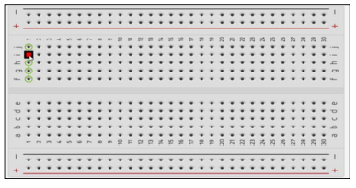

**Edge  
  
  
  
 Main Area  
  
  
  
  
 Edge**

1. List the electronic components used in a circuit assembly
2. Wire
3. LED
4. Potentiometer
5. Switch
6. Connector
7. Sensor
8. Battery
9. Transformer
10. Capacitor
11. Resistor
12. Transistor
13. Diode
14. IC
15. Switching power supply
16. Fuse
17. Relay
18. Voltage Regulator
19. Resistor Network
20. Cables
21. Inductor